Pima-Maricopa Irrigation Project Education Initiative
2005-2006

Restoring water to ensure the
continuity of the Akimel O’otham
and Pee Posh tradition of agriculture

Arrival of the Overland Stage Lines: 1858

The Gadsden Purchase initiated increased traffic through the Pima villages as emigrants from the east set out for California. To encourage travel, the United States Government authorized the War Department to explore and survey possible transportation routes. The Army Corps of Engineers, however, took too long to construct roads, at least in the opinion of California Senator John B. Weller. Private contractors, Weller argued, would “wield shovels and pickaxes with vigor,” unlike the Corps of Engineers, which, according to the Senator, was too focused on collecting geological or botanical information to the neglect of actual construction.
Part 66

Congress approved four new roads to the west coast in 1857, one of which left Franklin, Texas (present El Paso) and stretched to San Diego by way of the Pima villages and the lower Gila River. Appointed superintendent of the “El Paso to Ft. Yuma Wagon Road” was Jesse B. Leach of Stockton, California. Leaving Memphis, Tennessee with forty wagons and dozens of men amassed for the construction job, Leach divided the work into sections, with Engineer N. P. Cook directed to the Pima villages to set up camp and work west towards Ft. Yuma. When completed, Leach’s wagon road followed the Gila Trail from the Pima villages west to the Colorado River. Going east, however, the road followed the Gila Trail to a point fifteen miles downstream from the mouth of the San Pedro River, at which point it turned to the southeast continuing upstream to the 32nd parallel, where it maintained an easterly direction following the Parke railroad survey of 1854.
The wagon road differed from the old emigrant trail that came up from Tucson to the Pima villages. While still passing through the Pima villages, Leach’s road went through the San Pedro Valley—instead of the Santa Cruz Valley—because of the year-around flow of water and abundance of grass found in the former. The completed road was eighteen feet wide except through curves, when it expanded to twenty-five feet. When completed on October 1, 1858, the road bypassed Tucson, the preferred route for most travelers
Cook left no descriptions regarding the work done in and around the Pima villages. A Texan traveler named John Reid, however, passed through the villages in April 1857 and noted the Pima headmen remained concerned with the US acquisition of their land under the Gadsden Purchase Treaty, being particularly interested in whether or not the United States would recognize their land titles. Reid also pointed out the Pima had a “standing army” of some 1,500 warriors and that their villages extended downstream to the Maricopa villages on the south bank west of Pima Butte.
As the construction of the Pacific wagon roads continued, the government made all haste to establish semi monthly mail and transportation service to California. In June of 1857, the US Post Office awarded James E. Birch of the California Stage Company a four-year contract to deliver mail between San Antonio, Texas and San Diego, California. Called the “Jackass Mail” because of the use of mules to transport passengers across a 100-mile section of the California desert, the San Antonio and San Diego Mail Line began service on July 9, 1857 when the first stagecoach left for San Diego, arriving in San Diego on August 31. The first commercial means of travel across the west was established, although such travel required twenty-six days between San Antonio and San Diego.
The San Antonio and San Diego Mail Line constructed 87 stations between its two terminal cities, although only San Antonio, San Diego and El Paso had permanent and adequate buildings. The largest and most important stage stop outside of El Paso and San Diego was Maricopa Wells, which served as the dividing line between westbound and eastbound mail stops. While many of the stage stops were mere camping facilities, Maricopa Wells in 1857 had an adobe building complete with stock corrals. In time, it would grow and offer many amenities not found in Arizona outside of Tucson. Nonetheless, politicians in northern California were unhappy with the route, arguing, “the line ran from no place through nothing to nowhere.” There was truth to this, as passengers from the east traveled by steamboat to Indianola, Texas, before traveling 140 miles inland to San Antonio, where they began the 1,476-mile journey to San Diego. Passengers then boarded another steamboat to carry them to San Francisco. In between, they were frequently required to ride mule-back over especially arid desert areas. In the end, the mail line made just forty trips across the desert before it abandoned its Arizona routes in December 1858.
Far better known and much more dependable was the Butterfield Overland Mail Company, which began service between St. Louis, Missouri and Memphis, Tennessee in the east and San Francisco, California on September 16, 1858. Following the Southern Trail across Arizona through Tucson, the Pima villages and on into Ft. Yuma, the Butterfield line received a federal subsidy nearly four times that provided to the San Antonio and San Diego Mail line. Known as the “ox bow” route because of its deep southern bend between St. Louis and San Francisco, the overland route provided semi-weekly mail service.
John Butterfield spent a year planning and organizing the 2,700-mile long mail route, in the process raising $2,000,000 in capital to finance the stage line, which also received $600,000 annually in federal subsidies. He hired 750 men as drivers, station attendants, blacksmiths, messengers, hostlers and managers. Specially made coaches were constructed in New York and New Hampshire, with the infamous Concord coach used outside of the desert trails and a lightweight “Celerity Wagon” used to cross the desert reaches of Arizona and California.
Stage stations were about twenty miles apart, with construction materials for the seventeen stops in Arizona—including three within the Pima villages—consisting of adobe or simple timber and/or brush. An adobe wall and armed guards protected each station and its accompanying corral for stock. The stage line entered Tucson from the east with the station in Tucson located in modern downtown Tucson. The route then continued northwest out of Tucson along the present Union Pacific Railroad tracks before crossing to the west bank of the Santa Cruz River just north of Tucson. From here, the line followed the west bank of the Santa Cruz River until the road was forced back across to the east bank at the northern end of the Tucson Mountains at Point of Mountain., near where the Pointer Mountain stage station was located, eighteen miles northwest of Tucson.
The road continued in a straight line twenty-two miles northwest to Picacho Pass, the next station. It then followed a northwesterly direction fourteen miles to Blue Water, located three miles east of modern Toltec on the east side of the north branch of the Santa Cruz River. A well at Blue Water supplied water even during the driest seasons and plenty of grass was available for stock animals. The last westbound stop before the Pima villages was Oneida, located just southeast of present day Central Arizona College.
The Butterfield Overland route passed along the eastern slope of the Sacaton Mountains before veering northwest between Thin Mountain and Sacaton Peak. It then descended the alluvial plain and joined with Leach’s wagon road (modern State Route 87 east of Sacaton Flats) three miles east of Sacaton. Running along the south bank of the Little Gila River a mile and a half west of Sacaton, the road paralleled Casa Blanca Road to the station in Sacaton. Continuing west the road followed the south bank of the Little Gila (nearly along present Casa Blanca Road) until reaching Casa Blanca Station. This station, located near Ammi White’s trading post, was just west of the Vah Ki Presbyterian Church. Continuing another five miles west the trail split around either side of Pima Butte before descending into Maricopa Wells. Here the Butterfield Overland Mail Company constructed “a substantial group of adobe buildings and a large corral.
The Butterfield Overland Company ferried passengers across the desert and through the Pima villages until March of 1861, when the line ceased operations. By then, the Pony Express operated across a more northern route through Utah. After the start of the Civil War, the Butterfield Overland Company moved its entire operation north through Salt Lake City, Utah and Carson City, Nevada. Stage traffic in Arizona ceased to run for nearly a decade.
Arrival of the Overland Stage Lines: 1858
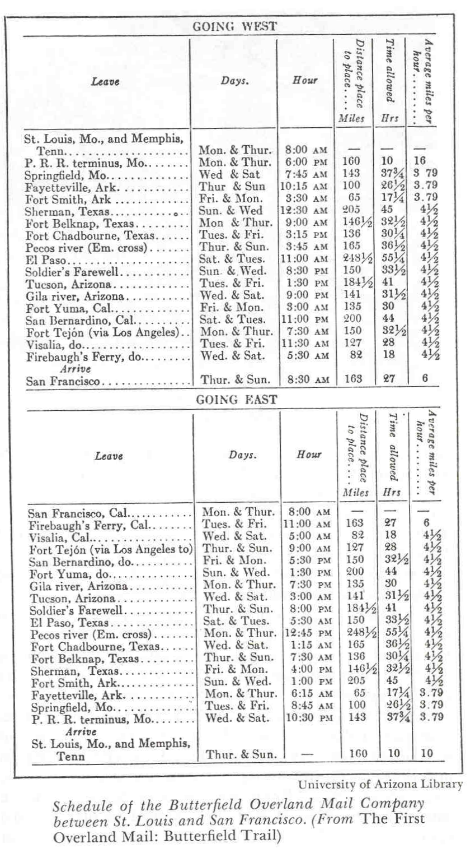

Teacher Plan for “Arrival of the Overland Stage Lines: 1858”
Objectives

Students will be able to:

- Explain the purpose for which the overland mail routes were established.

- Read and understand the stage schedule and be able to calculate distances and times required for various trips between El Paso and Ft. Yuma.
Terms to know and understand
- Botanical
- Semi
- Terminal
- Amenities
- Descending

Activities:
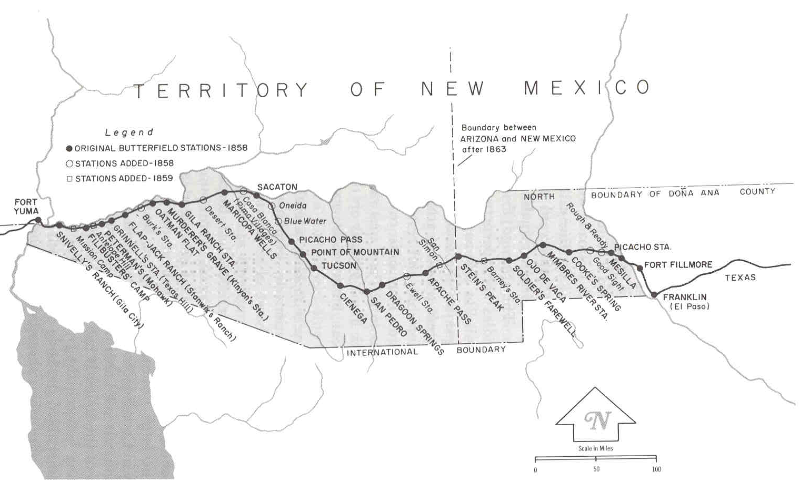
- Using the Butterfield schedule on page 23 and the Butterfield station map above, answer the following:
- If you were an eastbound passenger, on which day of the week and at what time would the stage leave Gila River (Maricopa Wells)?
- How many hours would it take to travel from Tucson to Maricopa Wells (Gila River)?
- If you left El Paso for San Francisco, how many hours would the trip take?
About P-MIP

The Pima-Maricopa Irrigation Project is authorized by the Gila River Indian Community to construct all irrigation systems for the Community. When fully completed, P-MIP will provide irrigation for up to 146,330 acres of farmland. P-MIP is dedicated to three long-range goals:
- Restoring water to the Akimel O’otham and Pee Posh.
- Putting Akimel O’otham and Pee Posh rights to the use of water to beneficial use.
- Demonstrating and exercising sound management to ensure continuity of the Community’s traditional economy of agriculture.

